Database System Design Term Project
Video Store

Submitted by: Jolanta Soltis
Ron Robinson
Date: 5/3/06
Instructor: Prof. Vincent Oria
Course: 631

Table of Contents

Table of Contents 2
1 Introduction 5
1.1 Purpose 5
1.2 Scope 5
1.2.1 Software System: 5
1.2.2 Software Documentation: 5
1.2.3 Operations Manual: 5
1.2.4 User’s Manual: 5
1.3 Definitions, acronyms, abbreviations 5
1.4 References 6
The phpMyAdmin Project (2005). Retrieved April 20 2006, from the World Wide Web: http://www.phpmyadmin.net/home_page/index.php 6
Elmasri, R. Navathe, S. B. (2004) Fundamentals of Database Systems: Addison-Wasley2 General Description 6
2 General Description 6
2.1 Product Perspective 8
2.1.1 System Interface 8
2.1.2 User Interface 8
2.1.3 Hardware Interface 8
2.1.4 Communication Interface 8
2.3 Users Characteristics 10
2.4 General Constraints 10
2.5 Assumptions and Dependencies 10
2.6 Issues/Problems Encountered 10
3. Specific Requirements 10
3.1 Functional Requirements 11
3.1.1 User Access 11
3.1.2 Video Store Catalog 12
3.1.3 Video Stores 13
3.1.4 Video Store Employees 13
3.1.5 Video Store Customers 14
3.1.6 Video Store Transactions 14
3.1.7 Video Store Reports 15
3.2 External interface requirements. 15
3.2.1 User Interfaces 16
3.2.2 Hardware Interfaces 16
3.2.3 Software Interfaces 16
3.3 Performance requirements 16
3.3.1 Transaction Speed 16
3.3.2 System Load 16
3.4 Design constraints 16
3.4.1 Application Design 16
3.5 Attributes 16
3.5.1 Reliability 16
3.5.2 Availability 16
3.6 Other requirements 17
3.6.1 Test and Training Mode 17
3.6.2 Help and User Documentation 17
4. Appendix –A – Data Base Design and Information 17
4.1 E-R Diagram 18
Figure2. ER diagram4.1.1 Design Philosophy 18
4.1.1 Design Philosophy 19
4.2 E-R to Relational Mapping 19
4.3 Database Schema 23
4.3.1 CUSTOMER Table 23
5 Appendix – B – Table Creation Scripts 36
5.1 CUSTOMER Table 36
5.2 EMPLOYEE Table 36
5.3 ITEM Table 37
5.4 ITEMCATALOG Table 37
5.5 MOVIES Table 37
5.6 REQUEST Table 37
5.6 STORE Table 38
5.7 TRANSACTION Table 38
5.8 VCR Table 38
5.9 VIDEO CAMERA Table 39
6. Appendix – C – Pseudo-Code 39
6.1 Movie: adding, deleting, or updating 39
6.2 VCR: adding, deleting, or updating 39
6.3 Video camera: adding, deleting, or updating 40
6.4 Adding a single copy of a movie or equipment (video camera, vcr) 40
6.5 Store: adding, deleting, or updating 40
6.6 Customer: adding, deleting, or updating 40
6.7 Employee: adding, deleting, or updating 41
6.8 Creating a request transaction 41
6.9 Adding item to a transaction 41
6.10 Removing item from transaction 42
6.11 Closing a transaction 42
6.12 Total number of outgoing movies per store and per month 42
6.13 Average number of rentals per customer 42
6.14 Ten Most frequently reserved titles for the last year 43
6.15 100 Best Customers ($$$$) 43
6.16 Total number of outgoing movies per store and per month 43
6.17 Monthly revenue of the company for the 12 months 43
7. Appendix – D – Application User Guide 43
7.1 Catalog Information Screen 44
7.1.1 Movie Information Screen 46
7.1.2 Video Camera Information Screen 47
7.1.3 VCR Information Screen 48
7.2 Stores Information Screen 49
7.2.1 Add/Edit Store Information Screen 50
7.3 Employee Information Screen 51
7.3.1 Add/Edit Employee Information Screen 53
7.4 Customers Information Screen 55
7.4.1 Add/Edit Customers Information Screen 56
7.5 Transactions Information Screen 57
7.5.1 Add/Edit Transactions Information Screen 58
7.6 Reports Information Screen 59
7.6.1 Reports Information Screen: Total number of outgoing movies per store and per month 61
7.6.2 Reports Information Screen: Average number of rentals per customer 62
7.6.3 Reports Information Screen: Ten Most frequently reserved titles for the last year 63
7.6.4 Reports Information Screen: 100 Best Customers ($$$$) 64
7.6.5 Reports Information Screen: Average number of outgoing movies per store 65
7.6.6 Reports Information Screen: Monthly revenue of the company for the 12 months 66
Table of Figures 67
Table of Tables 67

1. Introduction

1.1 Purpose
The purpose of this document is to provide a summary of system requirements, database design, and application user guide for the development of the Video Store Management System (VSMS). It also presents the Web Page Requirements Specification necessary for formal review by the customer. It defines and describes the operations, interfaces, performance, and quality assurance requirements of the software.

1.2 Scope
The objective of the project is to describe the software requirements of the Video Store Management System. The system will facilitate an information system that a video company can use to manage the rentals of videos and video equipment. The deliverable product will be referred to as the Video Store Management System (VSMS) and will be a package that includes the following.

1.2.1 Software System:
This will be a software product that will be client server application used by multiple users at several locations. Users will be able to interface with the system via Web Page while connected to the Internet. The system will provide communication to a centralized MySQL database system. The system is created by using PHP language

1.2.2 Software Documentation:
Complete and easily understood documentation of the software will be provided to aid in future maintenance and/or modification of software.

1.2.3 Operations Manual:
Used by employees of the video store. It will explain everything necessary to operate, maintain and configure the application to customer specifications.

1.2.4 User’s Manual:
It is a guide for all managers and personnel. It will explain how to use the VSMS. It will include diagrams to illustrate the steps to be performed and the parts of the system.

1.3 Definitions, acronyms, abbreviations

Terms | Definition
Database (DB) | A collection of information organized in such a way that a computer program can quickly select desired pieces of data.
DBMS | Database Management Systems: a collection of applications that enables you to store, modify, an extract information from a database.
VSMS | Video Store Management System, described in this document
SQL | Abbreviation of structured query language. Standardized query language for requesting information from a database.
MySQL | Software which is using SQL language and allows users to create databases. Available under Open Source license and commercial licenses.
PHP | Hypertext Preprocessor, an open source, server-side, HTML embedded scripting language used to create dynamic Web pages.
E-R | Entity Relationship Diagram; a graphical representation of entities and their relationships to each other.
HTML | HyperText Markup Language, the authoring language used to create documents on the World Wide Web.
Internet | A global network connecting millions of computers.
Table1. Definitions, acronyms, abbreviations

1.4 References

The phpMyAdmin Project (2005). Retrieved April 20 2006, from the World Wide Web: http://www.phpmyadmin.net/home_page/index.php
Elmasri, R. Navathe, S. B. (2004) Fundamentals of Database Systems: Addison-Wasley

2. General Description

The VSMS web page will perform as an information system described in the system requirements specifications of the Video Store. The product will provide necessary information via a web page to manage video, video camera and camcorder rentals and reservations and returns. The VSMS will have the ability to be scalable, which means it will be able to functions is or if it is or if it is changed in size or volume to meet a user needs. The architecture of VSMS will be open which will allow the customer to add to the system and adapt it as necessary.
The store will have catalog. The catalogue of movies contains the title of the movie, the producer, the director, two lead actors, the category of movie, the number of VHS cassettes and DVDs, and charge per day.
VideoStore carries multiple copies of the same title, and a store could have been assigned any number of copies of each title. A store that has more copies of a given title than assigned to it will return these at the end of each week to VideoStore head once, which redistributes them to appropriate stores. Store has inventory of all items and the web page they will be using has an management capabilities to:
Query, add, update, and remove movie, and equipment.
Show status of movie, and equipment.
Show rentals of items.
Handle reservation, rental and returning of movies and equipments by members.
Manage payments for rental by members (including late charges).

This application allows the employees to:

Query, add, update, and remove members.
Show status of a member, including titles borrowed and outstanding amount for items rented.
Show reserved titles by members.
This application should allow the employees to obtain:
Obtain total number of outgoing movies per store and per month.
View the average number of rental days per store (or per customer, or per title or just average number of rental days)
View 10 most frequently reserved titles for the last year.
V iew100 best customers (in terms of money paid to the company)
View average number of outgoing movies per store.
View monthly revenue of the company for the 12 months.

2.1 Product Perspective

2.1.1 System Interface
The web page resides on a server. Connection to the Internet is required to interact with database.
- A user’s Web browser issues an HTTP request for a particular Web page.
- Web Server receives the request, retrieves the file and passes it the PHP engine for processing.
- The PHP engine begins parsing the script. Connect to the database, execute a query.
- MySQL server receives the database query and processes it, sends the results back to the PHP engine.
- Browsers receives request.

2.1.2 User Interface
A variety of users will need to access to the VSMS. Web page will be used as the primary user interface. This will be the entry point into the system.

2.1.3 Hardware Interface
Users will access the product remotely using their personal computers from any of the video stores.

2.1.4 Communication Interface
The application will interface into a corporate database.

User
User
PHP

Application server
MySQL
Database server
Internet
User
Video Store

Figure1, High Level Diagram of the VSMS

2.2 Product Functions
The VSMS application will perform the following functions:

- Provide user authentication/access levels (Not implemented for demo).
- Store information about stores.
- Store information about employees.
- Store information about customers.
- Store information about transactions.
- Store information about movies
- Store information about video cameras.
- Store information about VCRs.
- Store information about rentals.
- Provide catalog of all movies.
- Provide reports:
- Total number of outgoing movies per store and per month
- Average number of rentals per customer
- Ten Most frequently reserved titles for the last year
- 100 Best Customers ($$$$)
- Average number of outgoing movies per store
- Monthly revenue of the company for the 12 months

2.3 Users Characteristics
We assume that the users will be managers, and sales associates. We assume that these users have limited computer background and will require an easy-to-use interface.
We assume that the managers will receive training in VSMS. The users will be provided with reference materials, instructions, and documentation for the software. The user’s manual and any help will be available electronically via the software.

2.4 General Constraints
The following general design constrains for VSMS:
- The system is protected and available only after authenticating by using User Name and Password.
- The application is available as a web page. Connection to the Internet is necessary.

2.5 Assumptions and Dependencies

The following are the assumptions and dependencies for VSMS;
- The DBMS will be running on a remote web server.
- The company will provide computers with Internet connection.
- PHP and MySQL will be installed on web server where database will reside.
- All customers must have and pay for the rentals by using credit cart.

2.6 Issues/Problems Encountered
- The first issues encountered where with the E_R diagram. After discussion E-R was corrected.

3. Specific Requirements
This section will contain the detailed requirements for the application. The requirements will be uniquely identifiable by using the following prefix syntax:
<F.F-PPPP>-R.NNN.nnn

Where F.F is the product release, PPPPP is the product name, R is the type of object being numberd. R, for detailed system requirements, O, for optional requirements.
NNNN.nnn is a numeric value to distinguish the requirements within the document. NNNN represents a requirement and will range from 1-9999. nnn represents the optional sub-requirement number, which will range from 1-999

In this document F.F will be 1.0 representing the first release and PPPP will be VSMS for Video Store Management System.

3.1 Functional Requirements

3.1.1 User Access
<1.0-VSMS>R.1 The application must provide a user interface for Video Store for r enting videos, video cameras and camcorders.
<VSMS>-R.1.1 The application authentication must use a user login and encrypted password.
<VSMS>-R.1.2 The application must provide the user role authorization that should provide way of assigning users to specific operations and tasks.
<VSMS>-R.1.3 The application must provide the means for the end user to define the application’s operations and tasks.

Rational: various employees will use the system across various stores. The system needs to be protected from unauthorized users/access to prevent malicious activities. The application will need to provide the means to limit access and functions of the system by user. A manager may have the ability to create, modify, and delete information, but a sales associate can only rent or reserve movies and equipment or view information about customers. The system must be flexible in allowing the customer define the level of authorization. Note: authorization and the access is not provided for the demo.

3.1.1.1 Inputs
- Login (An alphanumeric identifier containing at least 4 but no more than 30 characters and at least one number, it must be unique.)
- Password (An alphanumeric code containing at least 7 but no more than 20 characters. It must contain at least one alpha character and at least one numeric character.)

3.1.1.2 Processing
Upon the user entering their Login and Password the system shall authenticate the user checking for a valid Login ID and Password. If the user enters an invalid Login or Password then a message shall be displayed indicating that the login attempted failed. If the same Login ID failed 3 times in a row then that ID must be locked out. A message shall be displayed indicating that the maximum number of failed Login attempts has been reached and an administrator must reset the Login ID. Else if the user is valid then they shall be presented with their appropriate entry screen. If the user is logging into the application for the first time they must be prompted to change their password.

3.1.1.3 Outputs
- Login screen
- Error message indicating failed login attempt or maximum failed attempts.
- Appropriate user entry screen after successful login.

3.1.2 Video Store Catalog
<1.0-VSMS>-R.2 The application must be able to view the Catalog.
<VSMS>-R.2.1 The application must be able to add a new movie.
<VSMS>-R.2.1 The application must be able to edit every movie.
<VSMS>-R.2.1 The application must be able to add copy of a movie.
<VSMS>-R.2.1 The application must be able to delete a copy of a movie.

<VSMS>-R.2.1 The application must be able to add a new video camera.
<VSMS>-R.2.1 The application must be able to edit different types of cameras
<VSMS>-R.2.1 The application must be able to add copy of a video camera.
<VSMS>-R.2.1 The application must be able to delete a copy of a video camera.

<VSMS>-R.2.1 The application must be able to add a new vcr
<VSMS>-R.2.1 The application must be able edit different types of vsr’s
<VSMS>-R.2.1 The application must be able to add copy of a VCR.
<VSMS>-R.2.1 The application must be able to delete a copy of a VCR.

Rational: The video Store is in the business of renting videos and video equipment. Add the information about all that the store has should be listed and available to view.

3.1.2.1 Inputs
User will input necessary information to perform desired action.
They can choose to add a new movie or edit an existing movie.
In the “add new movie window” employee will enter: Movie Name, Director, Producer, Charge Per Day, Actor, Actor 2, URL of an image.
3.1.2.2 Processing
The application will search for an existing movie by using unique id.
The application will retrieve existing movie information.
The application will open new browser window to create new record for a new movie.
When “Update” button clicked all new record will be added to the database.
When “Cancel” button clicked user will go back to the previous window.
If the movie is new then the application must assign a new id and populate the movie information in the database.
From the existing movie when clicked on “Add New Copy” new copy is created and new id is allocated for that copy.
If “Delete” clicked movie is deleted from the database.
3.1.2.3 Output
New window used to add new movie or view information about existing movie.
New window with existing movie information is displayed. If the movie is not available information about availability is shown. User is able to delete or add movie copy.

3.1.3 Video Stores
<1.0-VSMS>-R.3 The application must be able to view the all stores.
<VSMS>-R.3.1 The application must be able to add a new store
<VSMS>-R.3.1 The application must be able to edit every store

Rational: The system must allow users to see all the stores.

3.1.3.1 Inputs
User can choose to add a new store or edit existing store information.
They will input: Location, Country, Street, State, City, Zip Code
3.1.3.2 Processing
The application will search for an existing customer store.
The application will retrieve existing store information.
The application will open new browser window to add new store information.
The application will update any new store information.

3.1.3.3 Output
New window used to add new store or view information about existing store.

3.1.4 Video Store Employees
<1.0-VSMS>-R.4 The application must be able to view the all employees.
<VSMS>-R.4.1 The application must be able to add a new employee.
<VSMS>-R.4.1 The application must be able to edit every new employee information.

Rational: The system must allow users to view all the employees to manage them.

3.1.4.1 Inputs
User can choose to add a new employee or edit existing employee information.
User will type: First Name, Last Name, Minit, Street, State, City, Zip Code, Country, Title, Pay Type, Pay Rate, Store
3.1.4.2 Processing
The application will search for an existing employee.
The application will retrieve existing employee information.
The application will open new browser window to add new employee information.
The application will update any new information.
3.1.4.3 Output
New window used to add new employee or view information about existing store.

3.1.5 Video Store Customers
<1.0-VSMS>-R.5 The application must be able to view the all customers.
<VSMS>-R.5.1 The application must be able to add a new customers.
<VSMS>-R.5.1 The application must be able to edit every new customers information.

Rational: The system must allow users to view all the customers to manage them and give them right information and product.

3.1.5.1 Inputs
User can choose to add a new customer or edit existing customer information.
User will type: First Name, Last Name, Password, Phone, Driver License, Card Number, Card Type, Street, State, City, Zip Code, Country, Minit
3.1.5.2 Processing
The application will search for an existing customer.
The application will retrieve existing customer information.
The application will open new browser window to add new customer information.
The application will update any new information.
3.1.5.3 Output
New window used to add new customer or view information about existing store.

3.1.6 Video Store Transactions
<1.0-VSMS>-R.6 The application must be able to view the all transactions.
<VSMS>-R.6.1 The application must be able to add a new transaction.
<VSMS>-R.6.1 The application must be able to view and edit all request information.
<VSMS>-R.6.1 The application must be able to view and edit all rental information.
<VSMS>-R.6.1 The application must be able to view and edit all completed transactions information.

Rational: The system must allow users to view all the transactions to manage them.

3.1.6.1 Inputs
User can choose to add a new transaction or edit existing transaction: request, rent or completed transaction information.
When entering new transaction user will enter: Type, Customer, Due Date, Store
3.1.6.2 Processing
The application will search for an existing request.
The application will search for an existing rent.
The application will search for an existing completed transaction.
The application will retrieve existing request.
The application will retrieve existing rent.
The application will retrieve existing completed transactions.
The application will open new browser window to add new transaction.
The application will update any new information.

3.1.6.3 Output
New window used to add new customer
Window to view information about existing requests, rents, and completed transactions.

3.1.7 Video Store Reports
<1.0-VSMS>-R.7 The application must be able to view the all reports.
<VSMS>-R.7.1 The application must be able to view the total number of outgoing movies per store and per month.
<VSMS>-R.7.1 The application must be able to view the average number of rentals per customer
<VSMS>-R.7.1 The application must be able to view the ten most frequently reserved titles for the last year.
<VSMS>-R.7.1 The application must be able to view 100 Best Customers
<VSMS>-R.7.1 The application must be able to view average number of outgoing movies per store
<VSMS>-R.7.1 The application must be able to view the monthly revenue of the company for the 12 months

Rational: The system must allow users to view different types of reports.

3.1.7.1 Inputs
User can choose to view listed reports.
Total number of outgoing movies per store and per month
Average number of rentals per customer
Ten Most frequently reserved titles for the last year
100 Best Customers ($$$$)
Average number of outgoing movies per store
Monthly revenue of the company for the 12 months
3.1.7.2 Processing
The application will search for an existing report.
The application will retrieve report requested.
The application will calculate the total number of outgoing movies per store and per month.
The application will calculate the average number of rentals per customer.
The application will calculate the average number of outgoing movies per store.
The application will calculate monthly revenue of the company for the 12 months.
3.1.7.3 Output
The application will open new window with report requested.

3.2 External interface requirements.
N/A

3.2.1 User Interfaces
N/A

3.2.2 Hardware Interfaces
N/A

3.2.3 Software Interfaces
N/A

3.3 Performance requirements

3.3.1 Transaction Speed
N/A

3.3.2 System Load
N/A

3.4 Design constraints
N/A

3.4.1 Application Design
N/A

3.5 Attributes
Application should not have any downtime to allow customers rent via web.

3.5.1 Reliability
<1.0-VSMS>-R.8. The application must be thoroughly test to ensure that all functions of the system work properly.

3.5.2 Availability
<1.0-VSMS>-R.9. The application must have 99.9 percent uptime.

3.6 Other requirements

3.6.1 Test and Training Mode
<1.0-VSMS>R.10. the application must provide a mode for training and testing exercises. Employees need to be trained on the application and perform exercises to ensure preparedness.

3.6.2 Help and User Documentation
<1.0-VSMS>R.11. The application must provide online help and user documentation. If the users become unfamiliar with the system they will need easy access to help and user documentation.

4. Appendix –A – Data Base Design and Information

4.1 E-R Diagram
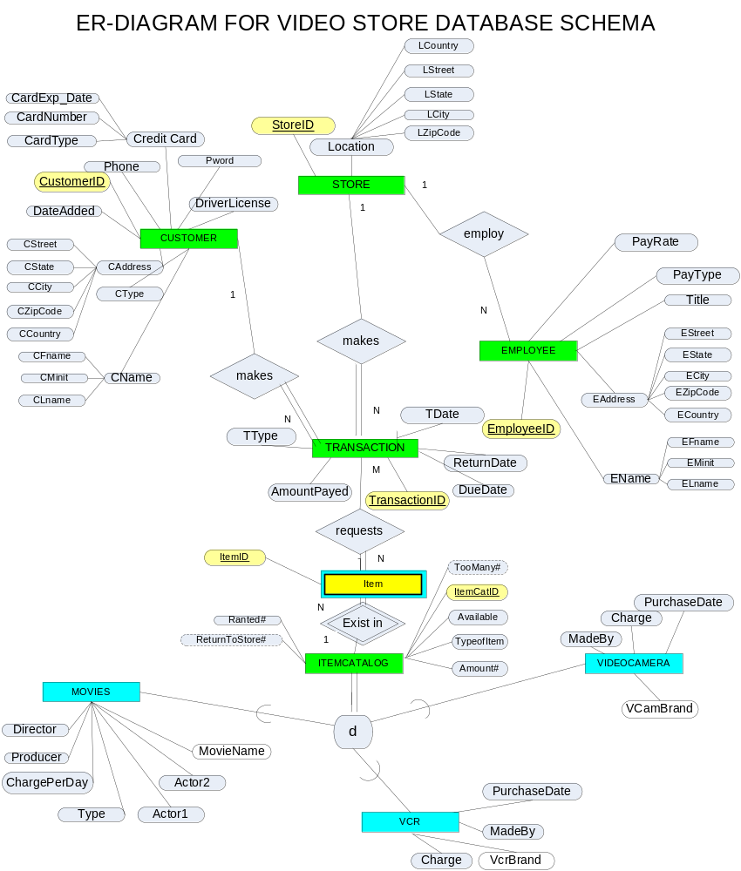

Figure2. ER diagram

4.1.1 Design Philosophy
The overall design philosophy was to keep the design simple but also flexible for future enhancements. The design was implemented to meet the requirements of the project demo and not full enterprise video rental application.
The EMPLOYEE table was straight forward and contains the attributes specified by the project requirements. The employee number is generated by a sequence number trigger and the unique key.
For the 1:N relation EMPLOY between EMPLOYEE and STORE the STOREID was added to the EMPLOYEE table as a new attribute.
STORE table is related to the CUSTOMER table by TRANSACTION table. The 1:N relation CREATES was created to connect TRANSACTION with STORE, and the 1:N relation MAKES was created to connect TRANSACTION with CUSTOMER.
In the CUSTOMER table CustomerID was used as the unique identifier. All customers who use video store are listed there. All customers have password to connect to the database to retrieve detail information (not included in the demo).
TRANSACTION is related by N:M relation REQUEST (which is a junction table) with ITEM table. ITEM table is a weak entity that is connected to the ITEMCATALOG table by 1:N relation EXIST. Every item is identified by ItemID and ItemCatID.

The specialization ITEM CATALOG type is needed because people can rent movies, vcr or video camera. These three categories have different attributes assign to them but are all items to rent.

4.2 E-R to Relational Mapping

4.2.1 Step 1- Handling Entities

STORE (StoreID, LCountry, LStreet, LState, LCity,LZipCode)

CUSTOMER (CustomerID, Pword, Phone, DriverLicense, DateAdded, CrediCard, CardExpDate, CardNumber,CardType, CType, CStreet, CState, CCity, CZipCode, CCountry, CFname, CMinit, CLname)

EMPLOYEE (EmployeeID, EFname, ELname, EMinit, EStreet, EState, ECity, EZipCode, ECountry, Title, PayType, PayRate)

TRANSACTION (TransactionID, TType, AmountPayed, DueDate, ReturnDate, TDate)

ITEM (ItemID)

ITEMCATALOG (ItemCatID, TooMany#, Available,TypeOfItem, Amount#, ReturnToStore#, Rented#)

MOVIES ( MovieName, Director, Producer, ChargePerDay, Type, Actor1, Actor2)

VCR ( Type, Charge, VcrBrand, MadeBy, PurchaseDate)

VIDEOCAMERA (VCamBrand, MadeBy, Charge, PurchaseDate)

4.2.2 Step2 – Weak Entities

ITEM (ItemID, ItemCatID, TransactionID)

4.2.3 Step 3 – 1:1 Relationships

No 1:1 relationship

4.2.4 Step 4 - 1:N relationship

STORE (StoreID, Location, LCountry, LStreet, LState, LCity,LZipCode)

CUSTOMER (CustomerID, Pword, Phone, DriverLicense, DateAdded, CrediCard, CardExpDate, CardNumber,CardType, CType, CStreet, CState, CCity, CZipCode, CCountry, CFname, CMinit, CLname)

EMPLOYEE (EmployeeID, EFname, ELname, EMinit, EStreet, EState, ECity, EZipCode, ECountry, Title, PayType, PayRate, StoreID)

TRANSACTION (TransactionID, TType, AmountPayed, DueDate, ReturnDate, TDate, StoreID, CustomerID)

ITEMCATALOG (ItemCatID, TooMany#, Available,TypeOfItem, Amount#, ReturnToStore#, Rented#)

ITEM (ItemID, ItemCatID, TransactionID)
4.2.5 Step 5 – M:N Relationship

No N:M relationship

4.2.6 Step 6 – Multi-Valued Attributes

No multi-valued attributes

4.2.7 Step 7 – Higher Order Relationships
N/A

4.2.8 Step 8 - Specialization

Superclass:

ITEMCATALOG (ItemCatID, TooMany#, Available,TypeOfItem, Amount#, ReturnToStore#, Rented#)

Subclass:

MOVIES (ItemCatID, MovieName, Director, Producer, ChargePerDay, Type, Actor1, Actor2)

VCR (ItemCatID, Type, Charge, VcrBrand, MadeBy, PurchaseDate)

VIDEOCAMERA (ItemCatID, VCamBrand, MadeBy, Charge, PurchaseDate)

4.2.9 Step 9 - Aggregation
No Aggregation

4.2.10 Final Set of Relations

STORE (StoreID, Location, LCountry, LStreet, LState, LCity,LZipCode)

CUSTOMER (CustomerID, Pword, Phone, DriverLicense, DateAdded, CrediCard, CardExpDate, CardNumber,CardType, CType, CStreet, CState, CCity, CZipCode, CCountry, CFname, CMinit, CLname)

EMPLOYEE (EmployeeID, EFname, ELname, EMinit, EStreet, EState, ECity, EZipCode, ECountry, Title, PayType, PayRate, StoreID)

TRANSACTION (TransactionID, TType, AmountPayed, DueDate, ReturnDate, TDate, StoreID, CustomerID)

ITEM (ItemID, ItemCatID, TransactionID)

ITEMCATALOG (ItemCatID, TooMany#, Available,TypeOfItem, Amount#, ReturnToStore#, Rented#)

MOVIES (ItemCatID, MovieName, Director, Producer, ChargePerDay, Type, Actor1, Actor2)

VCR (ItemCatID, Type, Charge, VcrBrand, MadeBy, PurchaseDate)

VIDEOCAMERA (ItemCatID, VCamBrand, MadeBy, Charge, PurchaseDate)

4.3 Database Schema

4.3.1 CUSTOMER Table
Column | Data Type | Nulls | Domain | Reference
CUSTOMERID | int(10/ | N | Sequence# | Unique identifier for a car class
CFNAME | Varchar(20) | Y |  | Customer first name.
CLNAME | Varchar(20) | Y |  | Customer last name.
CMINIT | Varchar(20) | Y |  | Customer middle initial.
CSTREET | Varchar(20) | Y |  | Customer address: street
CCITY | Varchar(20) | Y |  | Customer address: city
CZIPCODE | Varchar(20) | Y |  | Customer address: zip code
CCOUNTRY | Varchar(20) | Y |  | Customer address: country
PWORD | Varchar(20) | Y
PHONE | Varchar(20) | Y |  | Customer phone
DRIVERLICENSE | Varchar(20) | Y |  | Customer driver license
DATEADDED | Date | Y |  | Date customer was added to the database
CARDNUMBER | Varchar(20) | Y |  | Customer credit card number
CARDEXPDATE | Date | Y |  | Customer credit card expiration date
CARDTYPE | Varchar(20) | Y |  | Customer credit card type

Table2. Customer Table

Example:
1 | Ron | Robinson |  | 123 Broad St | NJ | Jersey City | 07000 | US | abc | 908-333-4545 | TA3434349349843 | 0000-00-00 | 11111111 | 0000-00-00 | Visa

Table3. Customer Table Example

Unique Index: CUSTOMERID

Purpose: Stores information about the customer.

An index was created for the PHONE since that is how a customer is queried by in the application.

4.3.1 EMPLOYEE Table

Column | Data Type | Nulls | Domain | Reference
EMPLOYEEID | int(6) | N | Sequence# | Unique identifier for an employee
STOREID | Int (4) | Y |  | Unique identifier for a store
EFNAME | Varchar(200) | Y |  | Employee first name
DLNAME | Varchar(200) | Y |  | Employee last name
EMININT | Varchar(200) | Y |  | Employee middle initial
ESTREET | Varchar(200) | Y |  | Employee address: street
ESTATE | Varchar(20) | Y |  | Employee address: state
ECITY | Varchar(200) | Y |  | Employee address: city
EZIPCODE | Varchar(10) | Y |  | Employee address: zipcode
ECOUNTRY | Varchar(200) | Y |  | Employee address: country
TITLE | Varchar(200) | Y |  | Employee title
PAYTYPE | Enum(‘manager,’assistantManager’, ‘partTime’) | Y |  | The type of his pay.
PAYRATE | Float(10,2) | Y | #######.## | Pay rate.

Table4. Employee Table

Example:
1 | 1 | Jane | Doe | 1 | 123 This way | NY | new York | 10280 | US | The Boss | manager | 20.00

Table5. Employee Table Example

Unique Index: employeeid

Purpose: Stores information about the customer.

4.3.2 ITEM Table

Column | Data Type | Nulls | Domain | Reference
ITEMID | int(6) | N | Sequence# | Unique identifier for an item.
ITEMCATALOG | Int (4) | Y

Table6. Item Table

Example:
2 | 1

Table7. Item Table Example

Unique Index: itemid

Purpose: single copy of a item: video, VCR or video camera.

4.3.3 ITEMCATALOG Table

Column | Data Type | Null | Domain | Reference
ITEMCATALOGID | int(6) | N | Sequence# | Unique identifier for an item catalog
TOOMANYCOUNT | Int (4) | Y |  | Counts if video store exceeds the mount of videos it shoud have
AVAILABLE | int(4) | Y |  | Shows available items
TYPEOFITEM | Enum (‘movie’,vcr’,’videocamera’) | Y |  | Shows the type of the item: movie, vcr, videocamera)
AMOUNTCOUNT | int(4) | Y |  | Shows the amount of items
RETURNTOSTORENUMBER | int(4) | Y |  | Shows how many should be return to the store
RENTEDCOUNT | Int(4) | Y |  | Show how many items are rented.

Table8. Item Catalog Table

Example:
1 | 0 | 0 | movie | 0 | 0 | 0

Table9. Item Catalog Table Example

Unique Index: itemcatlaolgid

Purpose: has all the items store has available to rent to customer.

Another index on “available” and “typeofitem” was created to retrieve available items and the type of them.

4.3.4 MOVIES Table

Column | Data Type | Nulls | Domain | Reference
ITEMCATALOGID | int(6) | N | Sequence# | Unique identifier for an item catalog
MOVIENAME | Varchar(200) | Y |  | Movie name
DIRECTOR | Varchar(200) | Y |  | Movie director
PRODUCER | Varchar(200) | Y |  | Movie producer
CHARGEPERDAY | Float(6,2) | Y |  | Charge per day
ACTOR1 | Varchar(200) | Y |  | Movie leading actor one
ACTOR2 | Varchar(200) | Y |  | Movie leading actor two
IMAGE | Varchar(255) | Y |  | Image of the movie.

Table10. Movies Table

Example:
1 | Star Wars: Episode III | George Lucas | George Lucas | 2.00 | Ewan McGregor | Natalie Portman | http://ec1.images-amazon.com/images/P/B00005JLXH.0...

Table11. Movies Table Example

Unique Index: itemcatalogid

Purpose: Has all the movies available to rent listed.

Another index was created by MOVIECATALOG, DIRECTOR, ACTOR1 AND ACTOR2 was created to retrieve wanted movies.

4.3.5 STORE Table

Column | Data Type | Nulls | Domain | Reference
STOREID | int(6) | N | Sequence# | Unique identifier for a store
LOCATION | Varchar(200) | Y |  | Store location
LCOUNTRY | Varchar(200) | Y |  | Store address: country
LSTREET | Varchar(200) | Y |  | Store address: street
LCITY | Varchar(200) | Y |  | Store address: city
LSTATE | Varchar(200) | Y |  | Store address: state
LZIPCODE | Varchar(10) | Y |  | Store address: zipcode

Table12. Store Table

Example:
1 | Fort Lee | US | 123 K-Street | Fort Lee | NJ | 07087

Table13. Store Table Example

Unique Index: storeid

Purpose: Has all video stores listed.

Another index by location was created to find out other stores location.

4.3.6 TRANSACTION Table

Column | Data Type | Nulls | Domain | Reference
TRANSACTIONID | int(6) | N |  | Unique identifier for a transaction
TTYPE | Enum(‘request’, ‘rent’) | N |  | Transaction type: request, rent
AMOUNTPAYED | Float(7,2) | Y | ####.## | Amount payed
DUEDATE | Date | Y |  | Due date
RETURNDATE | Date | Y |  | Return date
TDATE | Date | Y |  | Transaction date
STOREID | Int (4) | Y |  | Store unique identifier
CUSTOMERID | Int (4) | Y |  | Customer unique idnentifier
DISCOUNT | Float (7,2) | Y | ####.## | Discount amount
LATECHARGES | Float (7,2) | Y | ####.## | Late charges amount

Table14. Transaction Table

Example:
3 | rent | 5.00 | 2006-01-01 | NULL | 2006-04-22 | 1 | 1 | 0.00 | 0.00

Table15. Transaction Table Example

Unique Index: transactionid

Purpose: every transaction is recoreded in that table.

Another index on CUSTOMERID, LATECHARGES, RETURNDATE, TTYPE was created to retrieve necessary information requested by customers.

4.3.7 VCR Table

Column | Data Type | Nulls | Domain | Reference
ITEMCATALOGID | int(6) | N |  | Unique identifier for item catalog
TYPE | Varchar(100) | Y |  | The type of the VCR
CHARGE | Float (7,2) | Y |  | Charge
VCRBRAND | Varchar(100) | Y |  | VCR brand
MADEBY | Varchar(100) | Y |  | Made by
PURCHASEDATE | Varchar(20) | Y |  | Purchase date
IMAGE | Varchar(255) | Y |  | Image of the VCR

Table16. VCR Table

Example:
6 | Zenith | 10.00 | Zenith | Zenith | 4/1/2006 | http://www.circuitcity.com/IMAGE/product/list/zen/...

Table17. VCR Table Example

Unique Index: itemcatalogid

Purpose: Table has all VCRs listed.

An other index by VCRBRAND was created to retrieve requested information.

4.3.8 VIDEOCAMERA Table

Column | Data Type | Nulls | Domain | Reference
ITEMCATLOGID | int(6) | N |  | Unique identifier for an item catalog
VIDEOCAMERABRAND | Varchar(200) | Y |  | Video camera brand
MADEBY | Varchar(200) | Y |  | Made by
CHARGE | Float(7,2) | Y | ####.## | Charge to the customer
PURCHASEDATE | Varchar(20) | Y |  | Purchase date
IMAGE | Varchar(255) | Y |  | Image of the item.

Table18. VideoCamera Table

Example:
4 | Sony | Sony | 10.00 | 4/1/2006 | http://www.camcorderinfo.com/images/upload/Image/S...

Table19. VideoCamera Table Example

Unique Index: itemcatalogid

Purpose: Table has all video camera listed.

An other index by VIDEOCAMERABRAND was created to retrieve requested information.

4.3.9 REQUEST Table

Column | Data Type | Nulls | Domain | Reference
TRANSACTIONID | int(6) | N |  | Unique identifier for a transaction
ITEMID | Int (4) | Y |  | Unique identifier for a item.
ITEMCATALOGID | Int(4) | Y |  | Unique identifiter for an item catalog.

Table120. Request Table

Example:
2 | 2 | 1

Table21. Request Table Example

Unique Index:

Purpose: This table is a junction table between item and transaction to record every request.

5. Appendix – B – Table Creation Scripts

5.1 CUSTOMER Table
# Table structure for table customer
#

CREATE TABLE `customer` (
`customerId` int(10) unsigned NOT NULL auto_increment,
`cFName` varchar(200) default NULL,
`cLName` varchar(200) default NULL,
`cMinit` varchar(200) default NULL,
`cStreet` varchar(200) default NULL,
`cState` varchar(30) default NULL,
`cCity` varchar(100) default NULL,
`cZipCode` varchar(10) default NULL,
`cCountry` varchar(100) default NULL,
`pword` varchar(100) default NULL,
`phone` varchar(20) default NULL,
`driverLicense` varchar(200) default NULL,
`dateAdded` date default NULL,
`cardNumber` varchar(100) default NULL,
`cardExpDate` date default NULL,
`cardType` varchar(20) default NULL,
PRIMARY KEY (`customerId`)
) TYPE=MyISAM;

5.2 EMPLOYEE Table
# Table structure for table employee
#

CREATE TABLE `employee` (
`employeeId` int(6) unsigned NOT NULL auto_increment,
`storeId` int(4) default NULL,
`eFName` varchar(200) default NULL,
`eLName` varchar(200) default NULL,
`eMinit` varchar(200) default NULL,
`eStreet` varchar(200) default NULL,
`eState` varchar(20) default NULL,
`eCity` varchar(200) default NULL,
`eZipCode` varchar(10) default NULL,
`eCountry` varchar(200) default NULL,
`title` varchar(200) default NULL,
`payType` enum('manager','assistantManager','partTime') default NULL,
`payRate` float(10,2) default NULL,
PRIMARY KEY (`employeeId`),
KEY `employee_storeId` (`storeId`)
) TYPE=MyISAM;

5.3 ITEM Table
# Table structure for table item
#

CREATE TABLE `item` (
`itemId` int(6) unsigned NOT NULL auto_increment,
`itemCatalogId` int(4) default NULL,
PRIMARY KEY (`itemId`),
KEY `item_catalogId` (`itemCatalogId`)
) TYPE=MyISAM;

5.4 ITEMCATALOG Table
# Table structure for table itemcatalog
#

CREATE TABLE `itemcatalog` (
`itemCatalogId` int(6) unsigned NOT NULL auto_increment,
`tooManyCount` int(4) default NULL,
`available` int(4) default NULL,
`typeOfItem` enum('movie','vcr','videocamera') default NULL,
`amountCount` int(4) default NULL,
`returnToStoreNumber` int(4) default NULL,
`rentedCount` int(4) default '0',
PRIMARY KEY (`itemCatalogId`),
KEY `itemCatalog_type` (`typeOfItem`)
) TYPE=MyISAM;

5.5 MOVIES Table
# Table structure for table movies
#

CREATE TABLE `movies` (
`itemCatalogId` int(6) unsigned NOT NULL auto_increment,
`movieName` varchar(200) default NULL,
`director` varchar(200) default NULL,
`producer` varchar(200) default NULL,
`chargePerDay` float(6,2) default '0.00',
`actor1` varchar(200) default NULL,
`actor2` varchar(200) default NULL,
`image` varchar(255) default NULL,
PRIMARY KEY (`itemCatalogId`)
) TYPE=MyISAM;

5.6 REQUEST Table
# Table structure for table request
#

CREATE TABLE `request` (
`transactionId` int(6) unsigned NOT NULL default '0',
`itemId` int(4) default NULL,
`itemCatalogId` int(4) default NULL,
KEY `tran_item_catalog` (`transactionId`,`itemId`,`itemCatalogId`)
) TYPE=MyISAM;

5.6 STORE Table
# Table structure for table store
#

CREATE TABLE `store` (
`storeId` int(6) unsigned NOT NULL auto_increment,
`location` varchar(200) default NULL,
`lCountry` varchar(200) default NULL,
`lStreet` varchar(200) default NULL,
`lCity` varchar(200) default NULL,
`lState` varchar(200) default NULL,
`lZipCode` varchar(10) default NULL,
PRIMARY KEY (`storeId`)
) TYPE=MyISAM;

5.7 TRANSACTION Table
# Table structure for table transaction
#

CREATE TABLE `transaction` (
`transactionId` int(6) unsigned NOT NULL auto_increment,
`tType` enum('request','rent') default NULL,
`amountPayed` float(7,2) default NULL,
`dueDate` date default NULL,
`returnDate` date default NULL,
`tDate` date default NULL,
`storeId` int(4) default NULL,
`customerId` int(4) default NULL,
PRIMARY KEY (`transactionId`),
KEY `transaction_type` (`tType`),
KEY `transaction_customerId` (`customerId`),
KEY `transaction_storeId` (`storeId`)
) TYPE=MyISAM;

5.8 VCR Table
# Table structure for table vcr
#

CREATE TABLE `vcr` (
`itemCatalogId` int(6) unsigned NOT NULL auto_increment,
`type` varchar(100) default NULL,
`charge` float(7,2) default NULL,
`vcrBrand` varchar(100) default NULL,
`madeBy` varchar(100) default NULL,
`purchaseDate` varchar(20) default NULL,
`image` varchar(255) default NULL,
PRIMARY KEY (`itemCatalogId`)
) TYPE=MyISAM;

5.9 VIDEO CAMERA Table
# Table structure for table videocamera
#

CREATE TABLE `videocamera` (
`itemCatalogId` int(6) unsigned NOT NULL auto_increment,
`videoCameraBrand` varchar(200) default NULL,
`madeBy` varchar(200) default NULL,
`charge` float(7,2) default NULL,
`purchaseDate` varchar(20) default NULL,
`image` varchar(255) default NULL,
PRIMARY KEY (`itemCatalogId`)
) TYPE=MyISAM;

6. Appendix – C – Pseudo-Code

6.1 Movie: adding, deleting, or updating

Data submitted to catalog actions function

if button pressed is "delete" then
delete rows from itemCatalog, movie, and items
else if movieId does not exist
create new itemCatalog row, get item catalog id
create new movie row with itemCatalogId
else
update movie
end if

6.2 VCR: adding, deleting, or updating

Data submitted to catalog actions function

if button pressed is "delete" then
delete rows from itemCatalog, vcr, and items
else if vcrId does not exist
create new itemCatalog row, get item catalog id
create new vcr row with itemCatalogId
else
update vcr
end if

6.3 Video camera: adding, deleting, or updating

Data submitted to catalog actions function

if button pressed is "delete" then
delete rows from itemCatalog, videoCamera, and items
else if videoCameraId does not exist
create new itemCatalog row, get item catalog id
create new videoCamera row with itemCatalogId
else
update video camera
end if

6.4 Adding a single copy of a movie or equipment (video camera, vcr)

Clicking on the link underneath the update, delete, or cancel button
Link directs to catalog actions
Get typeOfItem from itemCatalogId
Create new item using itemCatalogId and itemId
Redirect to vcr, movie, or video camera view depending on typeOfItem

6.5 Store: adding, deleting, or updating

Data submitted to catalog actions function

if button pressed is "delete" then
delete rows from itemCatalog, store, and items
else if storeId does not exist
create new itemCatalog row, get item catalog id
create new store row with itemCatalogId
else
update store
end if

6.6 Customer: adding, deleting, or updating

Data submitted to catalog actions function

if button pressed is "delete" then
delete rows from itemCatalog, customer, and items
else if customerId does not exist
create new itemCatalog row, get item catalog id
create new customer row with itemCatalogId
else
update customer
end if

6.7 Employee: adding, deleting, or updating

Data submitted to catalog actions function

if button pressed is "delete" then
delete rows from itemCatalog, employee, and items
else if employeeId does not exist
create new itemCatalog row, get item catalog id
create new employee row with itemCatalogId
else
update employee
end if

6.8 Creating a request transaction

Select type: 'rent' or 'request'
Select customer
Choose a due date
Choose which store to rent from

Press the update button, date sent to transaction action class
Create transaction row and return user to transaction screen

6.9 Adding item to a transaction

Choose a movie to add to a transaction
Choose a vcr to add to a transaction
Choose a video camera to add to a transaction

Press the “add to transaction” button and take them to transaction action class

If user has chosen a movie:
Check if there is a copy of the movie available
If movie is available then
Create a request row with transactionId, itemId, itemCatalogId
End if

If user has chosen a vcr:
Check if there is a vcr available
If available is available then
Create a request row transactionId, itemId, itemCatalogId
End if

If user has chosen a video camera:
Check if there is a video camera available
If available is available then
Create a request row transactionId, itemId, itemCatalogId
End if

6.10 Removing item from transaction

Click on delete link
Remove from request table

6.11 Closing a transaction

If transaction type is rent then you’ll see additional fields for transaction
Input a discount
Input a late charge
Input a return date

At this point you can hit update and it will update the total on the scrren
You can then put in the amount paid

Send data to transaction action class
Update transaction with the data

6.12 Total number of outgoing movies per store and per month

Select stores order by location
For each store:
Select/Calculate total movies for each month for the store
Print results

6.13 Average number of rentals per customer

Select customers order by cFName
For each customer:
Select/Calculate avgerage movie total from transaction for the customer per transaction
Print results

6.14 Ten Most frequently reserved titles for the last year

Select movie and count of each movie rented, group by movies.itemCatalogId
Limit result to 10

6.15 100 Best Customers ($$$$)

Select/Calculate total amount paid per customer from customer and transactions

6.16 Total number of outgoing movies per store and per month

Select number of outgoing movies per store,
Then calculate average number of movies using the results.

6.17 Monthly revenue of the company for the 12 months

Select/calculate amount paid from transaction table, group by month

7. Appendix – D – Application User Guide

The following section will demonstrate how to use the web site.
The application is started by accessing web site: http://cis631.youon.com/?action=catalogView

7.1 Catalog Information Screen

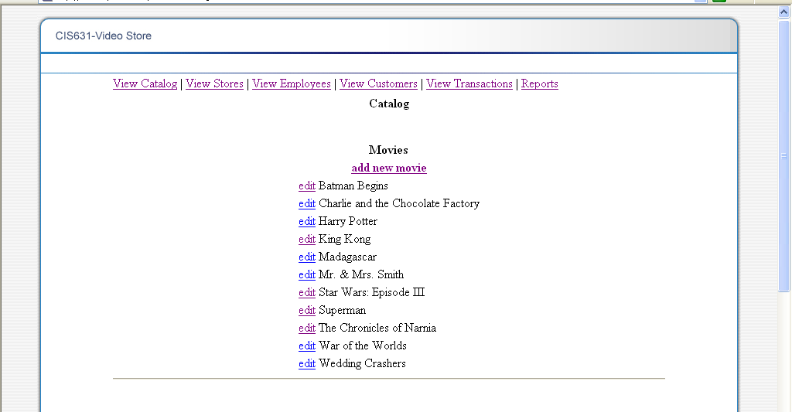
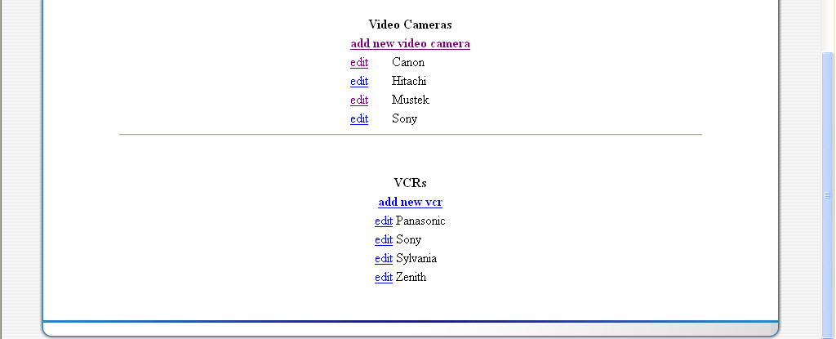
Figure3. Catalog Information Screen

Step | Action
1 | Click on the “add new movie” to add new movie to the catalog
2 | Click on the “edit” to view detail information about movie
3 | Click on the “add new video camera” to add new movie to the catalog
4 | Click on the “edit” to view detail information about specific video camera
5 | Click on the “add new vcr” to add new movie to the catalog
Step | Menu Options
1 | Click on the “ View Catalog” to access page which has catalog
2 | Click on the “View Stores” to access page which has list of all the stores
3 | Click on the “View Employees” to access page which has list of all the employees
4 | Click on the “View Transactions” to access page which has list of all the transactions
5 | Click on the “Reports” to access page which has list of all the reports
Table22. User Guide: Catalog Information Screen

7.1.1 Movie Information Screen

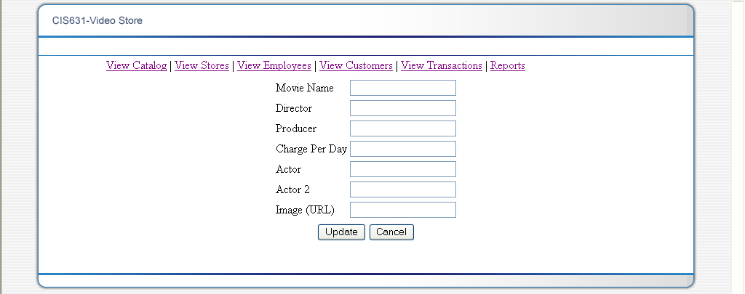

Figure4. Movie Information Screen

Step | Action
1 | Enter information about the movie
2 | Click on “Update” button to update new information
3 | Click on the “Cancel” to go back to the previous window
Step | Menu Options
1 | Click on the “ View Catalog” to access page which has catalog
2 | Click on the “View Stores” to access page which has list of all the stores
3 | Click on the “View Employees” to access page which has list of all the employees
4 | Click on the “View Transactions” to access page which has list of all the transactions
5 | Click on the “Reports” to access page which has list of all the reports

Table23. User Guide: Movie Information Scrren

7.1.2 Video Camera Information Screen

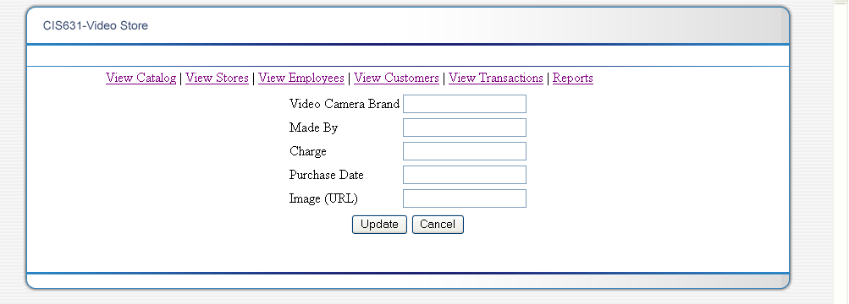

Figure5. Video Camera Information Screen

Step | Action
1 | Enter information about the video camera
2 | Click on “Update” button to update new information
3 | Click on the “Cancel” to go back to the previous window
Step | Menu Options
1 | Click on the “ View Catalog” to access page which has catalog
2 | Click on the “View Stores” to access page which has list of all the stores
3 | Click on the “View Employees” to access page which has list of all the employees
4 | Click on the “View Transactions” to access page which has list of all the transactions
5 | Click on the “Reports” to access page which has list of all the reports

Table24. User Guide: Video Sore Information Screen

7.1.3 VCR Information Screen

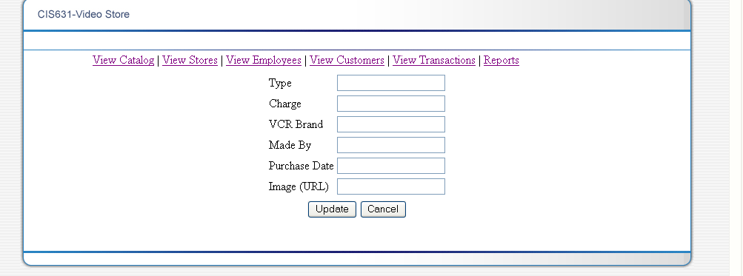

Figure6. VCR Information Screen

Step | Action
1 | Enter information about the VCR
2 | Click on “Update” button to update new information
3 | Click on the “Cancel” to go back to the previous window
Step | Menu Options
1 | Click on the “ View Catalog” to access page which has catalog
2 | Click on the “View Stores” to access page which has list of all the stores
3 | Click on the “View Employees” to access page which has list of all the employees
4 | Click on the “View Transactions” to access page which has list of all the transactions
5 | Click on the “Reports” to access page which has list of all the reports

Table25. User Guide: VCR Information Screen

7.2 Stores Information Screen

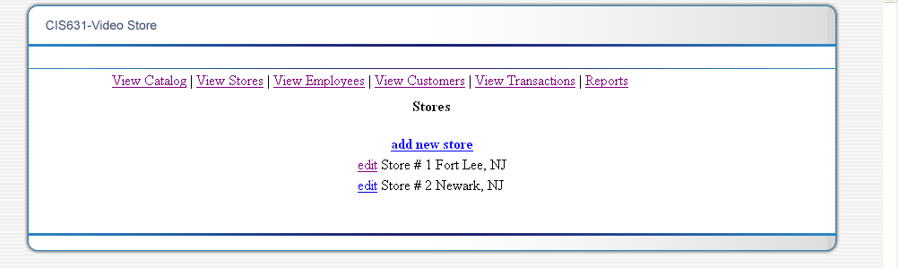

Figure7. Stores Information Screen

Step | Action
1 | Click on the “add new store” to add a new store
2 | Click on “edit’ to view or change information about any of the stores listed
Step | Menu Options
1 | Click on the “ View Catalog” to access page which has catalog
2 | Click on the “View Stores” to access page which has list of all the stores
3 | Click on the “View Employees” to access page which has list of all the employees
4 | Click on the “View Transactions” to access page which has list of all the transactions
5 | Click on the “Reports” to access page which has list of all the reports

Table26. User Guide: Stores Information Screen

7.2.1 Add/Edit Store Information Screen

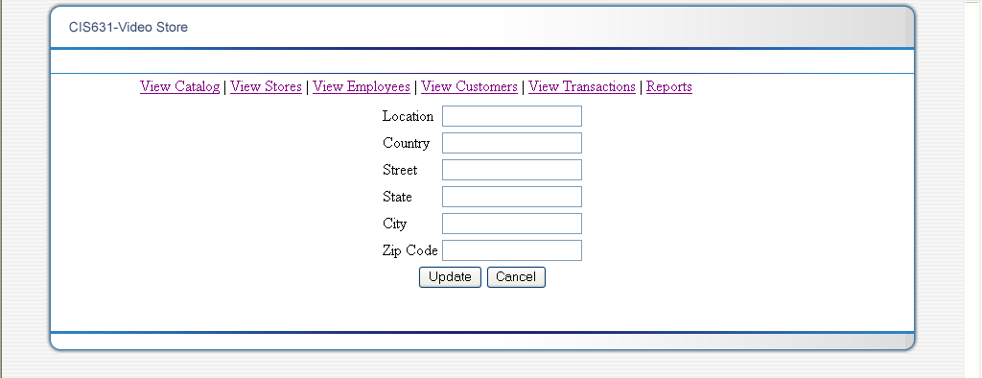

Figure8. Add/Edit Store Information Screen

Step | Action
1 | Enter information about the Store
2 | Click on “Update” button to update new information
3 | Click on the “Cancel” to go back to the previous window
Step | Menu Options
1 | Click on the “ View Catalog” to access page which has catalog
2 | Click on the “View Stores” to access page which has list of all the stores
3 | Click on the “View Employees” to access page which has list of all the employees
4 | Click on the “View Transactions” to access page which has list of all the transactions
5 | Click on the “Reports” to access page which has list of all the reports

Table27. User Guide: Add/Edit Store Information Screen

7.3 Employee Information Screen

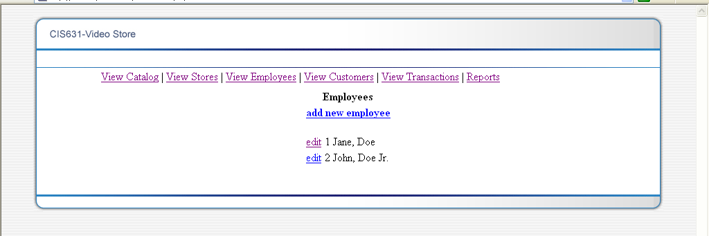

Figure9. Employee Information Screen

Step | Action
1 | Click on the “add new employee” to add a new employee
2 | Click on “edit’ to view or change information about any of the employee listed
Step | Menu Options
1 | Click on the “ View Catalog” to access page which has catalog
2 | Click on the “View Stores” to access page which has list of all the stores
3 | Click on the “View Employees” to access page which has list of all the employees
4 | Click on the “View Transactions” to access page which has list of all the transactions
5 | Click on the “Reports” to access page which has list of all the reports

Table28. User Guide: Employee Information Screen

7.3.1 Add/Edit Employee Information Screen

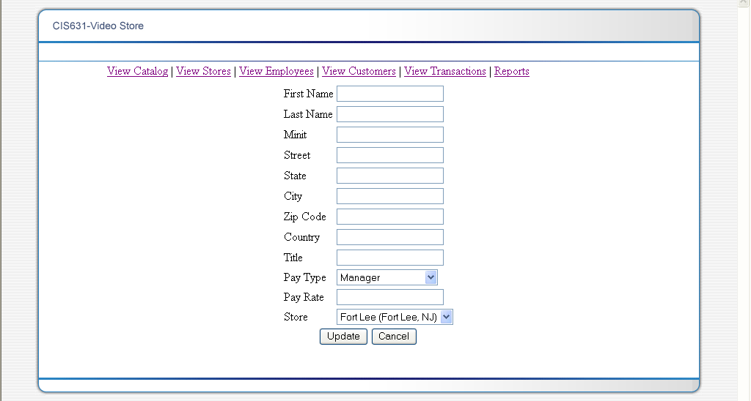

Figure10. Add/Edit Employee Information Screen

Step | Action
1 | Enter information about the Store
2 | Click on “Update” button to update new information
3 | Click on the “Cancel” to go back to the previous window
Step | Menu Options
1 | Click on the “ View Catalog” to access page which has catalog
2 | Click on the “View Stores” to access page which has list of all the stores
3 | Click on the “View Employees” to access page which has list of all the employees
4 | Click on the “View Transactions” to access page which has list of all the transactions
5 | Click on the “Reports” to access page which has list of all the reports

Table29. User Guide: Add/Edit Employee Information Screen

7.4 Customers Information Screen

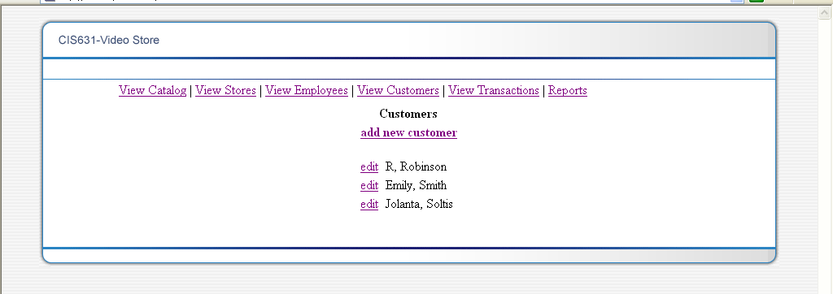

Figure11. Customers Information Screen

Step | Action
1 | Click on the “add new employee” to add a new employee
2 | Click on “edit’ to view or change information about any of the employee listed
Step | Menu Options
1 | Click on the “ View Catalog” to access page which has catalog
2 | Click on the “View Stores” to access page which has list of all the stores
3 | Click on the “View Employees” to access page which has list of all the employees
4 | Click on the “View Transactions” to access page which has list of all the transactions
5 | Click on the “Reports” to access page which has list of all the reports

Table30. User Guide: Customer Information Screen

7.4.1 Add/Edit Customers Information Screen

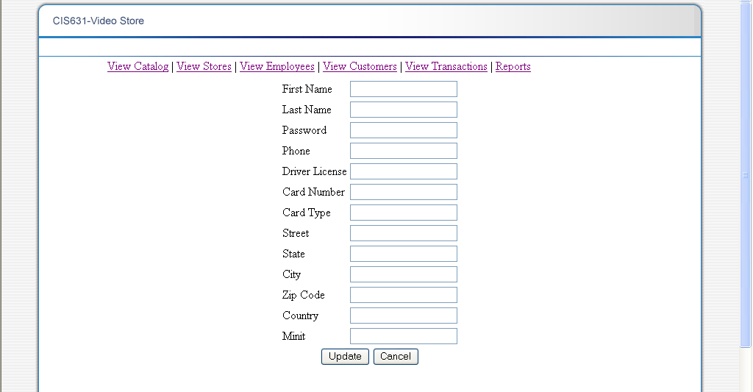

Figure12. Add/Edit Customers Information Screen

Step | Action
1 | Enter information about the Store
2 | Click on “Update” button to update new information
3 | Click on the “Cancel” to go back to the previous window
Step | Menu Options
1 | Click on the “ View Catalog” to access page which has catalog
2 | Click on the “View Stores” to access page which has list of all the stores
3 | Click on the “View Employees” to access page which has list of all the employees
4 | Click on the “View Transactions” to access page which has list of all the transactions
5 | Click on the “Reports” to access page which has list of all the reports

Table31. User Guide: Add/Edit Customers Information Screen

7.5 Transactions Information Screen

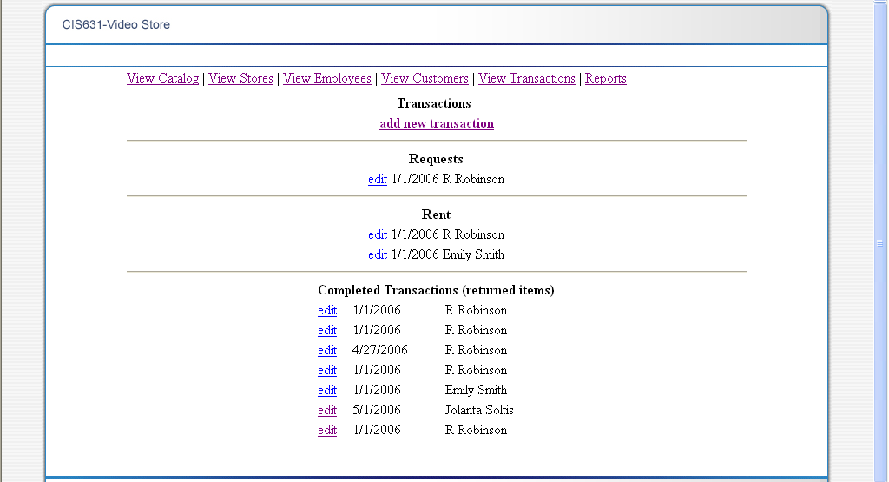

Figure13. Transaction Information Screen

Step | Action
1 | Click on the “add new employee” to add a new employee
2 | Click on “edit’ to view or change information about any of the employee listed
Step | Menu Options
1 | Click on the “ View Catalog” to access page which has catalog
2 | Click on the “View Stores” to access page which has list of all the stores
3 | Click on the “View Employees” to access page which has list of all the employees
4 | Click on the “View Transactions” to access page which has list of all the transactions
5 | Click on the “Reports” to access page which has list of all the reports

Table32. User Guide: Transaction Information Screen

7.5.1 Add/Edit Transactions Information Screen

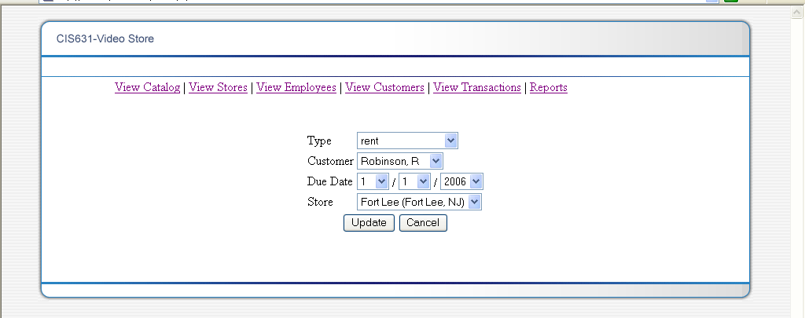

Figure14. Add/Edit Transaction Information Screen

Step | Action
1 | Enter information about the Store
2 | Click on “Update” button to update new information
3 | Click on the “Cancel” to go back to the previous window
Step | Menu Options
1 | Click on the “ View Catalog” to access page which has catalog
2 | Click on the “View Stores” to access page which has list of all the stores
3 | Click on the “View Employees” to access page which has list of all the employees
4 | Click on the “View Transactions” to access page which has list of all the transactions
5 | Click on the “Reports” to access page which has list of all the reports

Table33. User Guide: Add/Edit Transaction Information Screen

7.6 Reports Information Screen

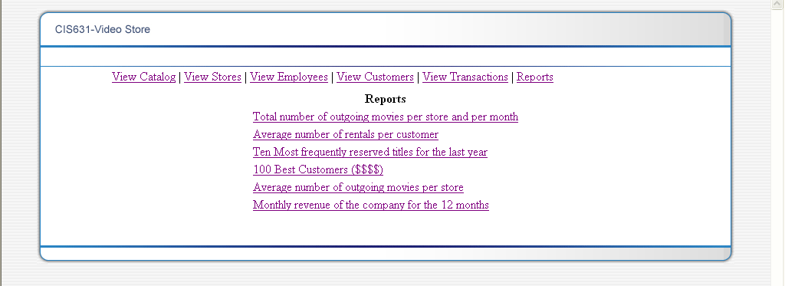

Figure15. Reports Information Screen

Step | Action
1 | Click on the “add new employee” to add a new employee
2 | Click on “edit’ to view or change information about any of the employee listed
Step | Menu Options
1 | Click on “Total number of outgoing movies per store and per month” to access report
2 | Click on “Average number of rentals per customer” to access report
3 | Click on “Ten Most frequently reserved titles for the last year” to access report
4 | Click on “100 Best Customers ($$$$)”to access report
5 | Click on “Average number of outgoing movies per store” to access report
6 | Click on “Monthly revenue of the company for the 12 months” to access report

Table34. User Guide: Reports Information Screen

7.6.1 Reports Information Screen: Total number of outgoing movies per store and per month

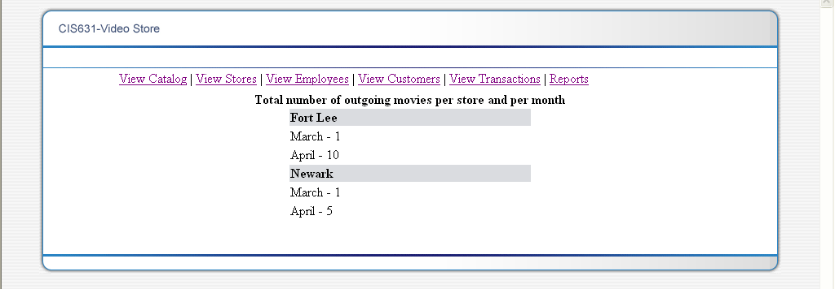

Figure16. Reports Information Screen: Total number of outgoing movies per store and per month

Step | Menu Options
1 | Click on “Total number of outgoing movies per store and per month” to access report
2 | Click on “Average number of rentals per customer” to access report
3 | Click on “Ten Most frequently reserved titles for the last year” to access report
4 | Click on “100 Best Customers ($$$$)”to access report
5 | Click on “Average number of outgoing movies per store” to access report
6 | Click on “Monthly revenue of the company for the 12 months” to access report

Table35. User Guide: Reports Information Screen: Total number of outgoing movies per store and per month

7.6.2 Reports Information Screen: Average number of rentals per customer

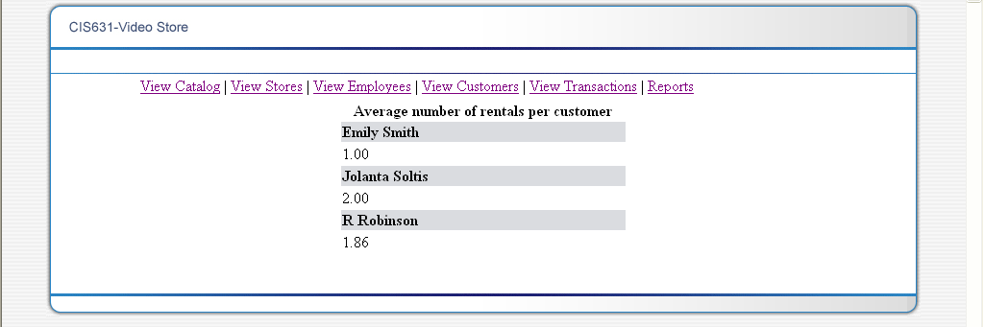

Figure17. Reports Information Screen: Average number of rentals per customer

Step | Menu Options
1 | Click on “Total number of outgoing movies per store and per month” to access report
2 | Click on “Average number of rentals per customer” to access report
3 | Click on “Ten Most frequently reserved titles for the last year” to access report
4 | Click on “100 Best Customers ($$$$)”to access report
5 | Click on “Average number of outgoing movies per store” to access report
6 | Click on “Monthly revenue of the company for the 12 months” to access report

Table36. User Guide: Reports Information Screen: Average number of rentals per customer

7.6.3 Reports Information Screen: Ten Most frequently reserved titles for the last year

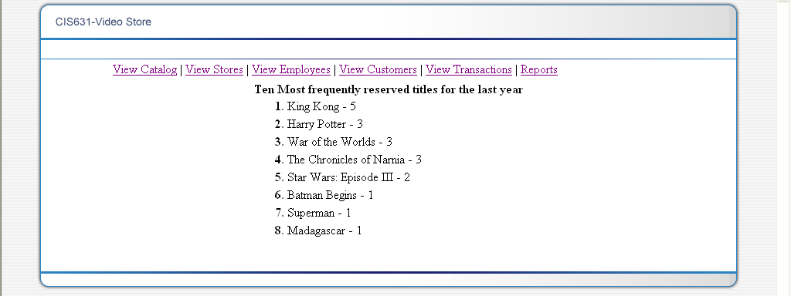

Figure18. Reports Information Screen: Ten Most frequently reserved titles for the last year

Step | Menu Options
1 | Click on “Total number of outgoing movies per store and per month” to access report
2 | Click on “Average number of rentals per customer” to access report
3 | Click on “Ten Most frequently reserved titles for the last year” to access report
4 | Click on “100 Best Customers ($$$$)”to access report
5 | Click on “Average number of outgoing movies per store” to access report
6 | Click on “Monthly revenue of the company for the 12 months” to access report

Table37. User Guide: Reports Information Screen: Ten Most frequently reserved titles for the last year

7.6.4 Reports Information Screen: 100 Best Customers ($$$$)

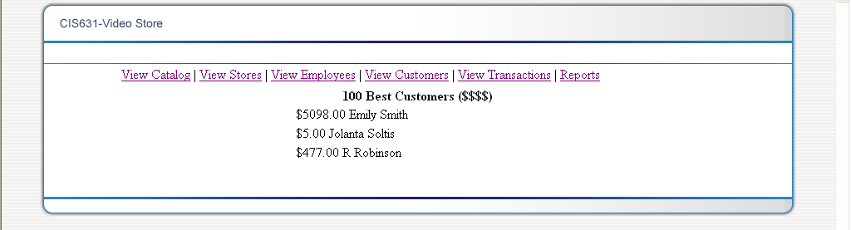

Figure19. Reports Information Screen: 100 Best Customers

Step | Menu Options
1 | Click on “Total number of outgoing movies per store and per month” to access report
2 | Click on “Average number of rentals per customer” to access report
3 | Click on “Ten Most frequently reserved titles for the last year” to access report
4 | Click on “100 Best Customers ($$$$)”to access report
5 | Click on “Average number of outgoing movies per store” to access report
6 | Click on “Monthly revenue of the company for the 12 months” to access report

Table38. User Guide: Reports Information Screen: 100 Best Customers

7.6.5 Reports Information Screen: Average number of outgoing movies per store

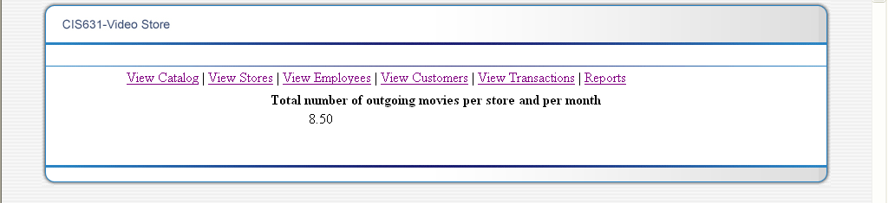

Figure20. Reports Information Screen: Average number of outgoing movies per store

Step | Menu Options
1 | Click on “Total number of outgoing movies per store and per month” to access report
2 | Click on “Average number of rentals per customer” to access report
3 | Click on “Ten Most frequently reserved titles for the last year” to access report
4 | Click on “100 Best Customers ($$$$)”to access report
5 | Click on “Average number of outgoing movies per store” to access report
6 | Click on “Monthly revenue of the company for the 12 months” to access report

Table39. User Guide: Reports Information Screen: Average number of outgoing movies per store

7.6.6 Reports Information Screen: Monthly revenue of the company for the 12 months

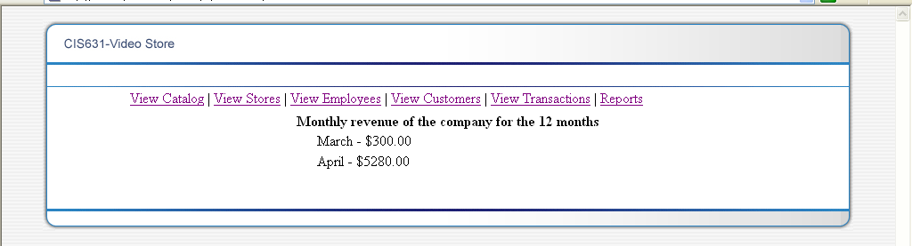

Figure21. Reports Information Screen: Monthly revenue of the company for the 12 months

Step | Menu Options
1 | Click on “Total number of outgoing movies per store and per month” to access report
2 | Click on “Average number of rentals per customer” to access report
3 | Click on “Ten Most frequently reserved titles for the last year” to access report
4 | Click on “100 Best Customers ($$$$)”to access report
5 | Click on “Average number of outgoing movies per store” to access report
6 | Click on “Monthly revenue of the company for the 12 months” to access report

Table40. User Guide: Reports Information Screen: Monthly revenue of the company for the 12 months

Table of Figures
Figure1, High Level Diagram of the VSMS 9
Figure2. ER diagram 18
Figure3. Catalog Information Screen 44
Figure4. Movie Information Screen 46
Figure5. Video Camera Information Screen 47
Figure6. VCR Information Screen 48
Figure7. Stores Information Screen 49
Figure8. Add/Edit Store Information Screen 51
Figure9. Employee Information Screen 52
Figure10. Add/Edit Employee Information Screen 53
Figure11. Customers Information Screen 55
Figure12. Add/Edit Customers Information Screen 56
Figure13. Transaction Information Screen 57
Figure14. Add/Edit Transaction Information Screen 59
Figure15. Reports Information Screen 60
Figure16. Reports Information Screen: Total number of outgoing movies per store and per month 61
Figure17. Reports Information Screen: Average number of rentals per customer 62
Figure18. Reports Information Screen: Ten Most frequently reserved titles for the last year 63
Figure19. Reports Information Screen: 100 Best Customers 64
Figure20. Reports Information Screen: Average number of outgoing movies per store 65
Figure21. Reports Information Screen: Monthly revenue of the company for the 12 months 66

Table of Tables
Table1. Definitions, acronyms, abbreviations 6
Table2. Customer Table 24
Table3. Customer Table Example 24
Table4. Employee Table 26
Table5. Employee Table Example 26
Table6. Item Table 26
Table7. Item Table Example 27
Table8. Item Catalog Table 28
Table9. Item Catalog Table Example 28
Table10. Movies Table 29
Table11. Movies Table Example 29
Table12. Store Table 30
Table13. Store Table Example 30
Table14. Transaction Table 32
Table15. Transaction Table Example 32
Table16. VCR Table 33
Table17. VCR Table Example 33
Table18. VideoCamera Table 34
Table19. VideoCamera Table Example 34
Table120. Request Table 35
Table21. Request Table Example 35
Choose a movie to add to a transaction 41
Table22. User Guide: Catalog Information Screen 45
Table23. User Guide: Movie Information Scrren 47
Table24. User Guide: Video Sore Information Screen 48
Table25. User Guide: VCR Information Screen 49
Table26. User Guide: Stores Information Screen 50
Table27. User Guide: Add/Edit Store Information Screen 51
Table28. User Guide: Employee Information Screen 52
Table29. User Guide: Add/Edit Employee Information Screen 54
Table30. User Guide: Customer Information Screen 56
Table31. User Guide: Add/Edit Customers Information Screen 57
Table32. User Guide: Transaction Information Screen 58
Table33. User Guide: Add/Edit Transaction Information Screen 59
Table34. User Guide: Reports Information Screen 61
Table35. User Guide: Reports Information Screen: Total number of outgoing movies per store and per month 62
Table36. User Guide: Reports Information Screen: Average number of rentals per customer 63
Table37. User Guide: Reports Information Screen o: Ten Most frequently reserved titles for the last year 64
Table38. User Guide: Reports Information Screen: 100 Best Customers 65
Table39. User Guide: Reports Information Screen: Average number of outgoing movies per store 66
Table40. User Guide: Reports Information Screen: Monthly revenue of the company for the 12 months 67

